Lab Manual for Web Application Development

##### Lab-2

HTML (Part 2)

**Lab Development Team**

**Course Instructor:**

Kausar Nasreen

Junior Lecturer

**Lab Instructor:**

Nayab Khalid kayani

Teaching Fellow

Page | 3

### Lab 02: HTML(Revision)

#### Introduction

HTML is the language in which most websites are written. HTML is used to create web pages and make them functional. It can be assisted by technologies such as Cascading Style Sheets (CSS) and scripting languages such as JavaScript.

##### Basic HTML Structure

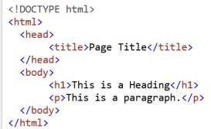

**Figure 1 Basic HTML**

The **<!DOCTYPE>** declaration is not an HTML tag; it is an instruction to the web browser about what version of HTML the page is written in. Here **<!DOCTYPE html>** represents we are using HTML 5.

**Tip:** Always add the <!DOCTYPE html> declaration to your HTML documents, so that the browser knows what type of document to expect. The opening **<html>** tag indicates that anything between it and a closing

**</html>** tag is HTML code. The **<head>** element is a container for metadata (data about data) and is placed between the **<html>** tag and the **<body>** tag. The **<title>** element defines the title of the document, and is required in all HTML documents.

The **<body>** tag indicates that anything between it and the closing **</body>** tag should be shown inside the main browser window. The words between **<h1>** and **</h1>** element are main heading, similarly words between **<p>** and **</p>** represents a paragraph.

In short

* The **<!DOCTYPE html>**declaration defines this document to be HTML5
* The **<html>**element is the root element of an HTML page
* The **<head>**element contains meta information about the document
* The **<title>**element specifies a title for the document
* The **<body>**element contains the visible page content
* The **<h1>**element defines a large heading
* The **<p>**element defines a paragraph

##### HTML Tags

HTML tags are element names surrounded by angle brackets:

Page | 4

**<tagname>**content goes here...**</tagname>**

* + - HTML tags normally come **in pairs** like **<p>** and **</p>**
    - The first tag in a pair is the **start tag,** the second tag is the **end tag**
    - The end tag is written like the start tag, but with a **forward slash** inserted before the tag name

##### HTML Attributes

Attributes provide additional information about HTML elements.

* + - All HTML elements can have **attributes**
    - Attributes provide **additional information** about an element
    - Attributes are always specified in **the start tag**
    - Attributes usually come in name/value pairs like: **name="value"**

Example:

**<a href[="https://www.w3schools.com">](http://www.w3schools.com/)This is a link</a>**

Similarly

###### <img src="img.jpg">

HTML images are defined with the **<img>**tag. The filename of the image source is specified in the **src**

attribute:

#### Concept Map

##### HTML Elements

An HTML element is defined by a start tag, some content, and an end tag.

**Example:**

<body>…</body>

<h1>…</h1>

<p>…</p>

Let’s understand that through practical example:

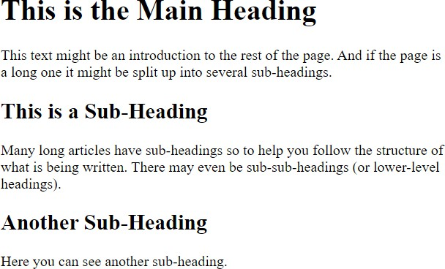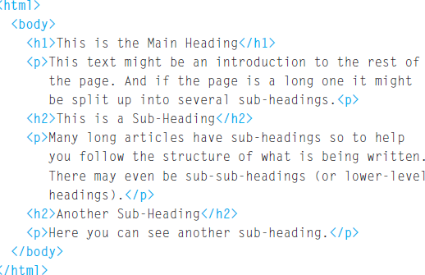

**Figure 2 HTML Output Figure 3 HTML Code**

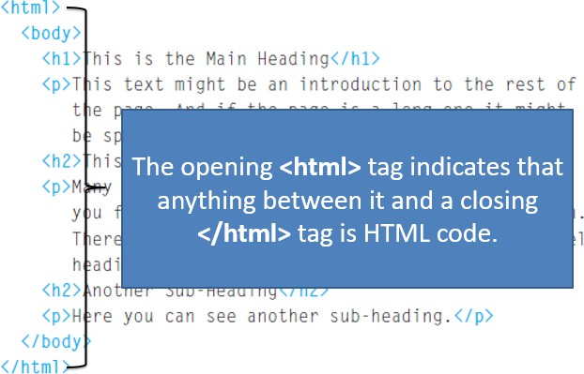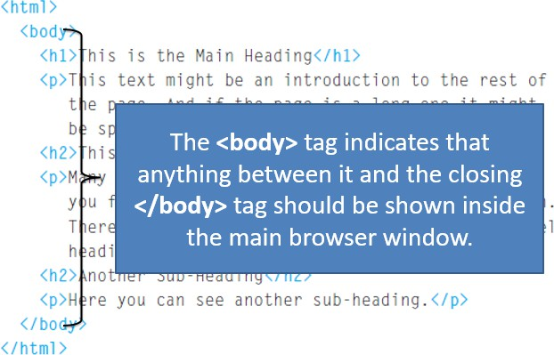

**Figure 5 HTML Tags Example 1 Figure 4 HTML Tags Example 2**

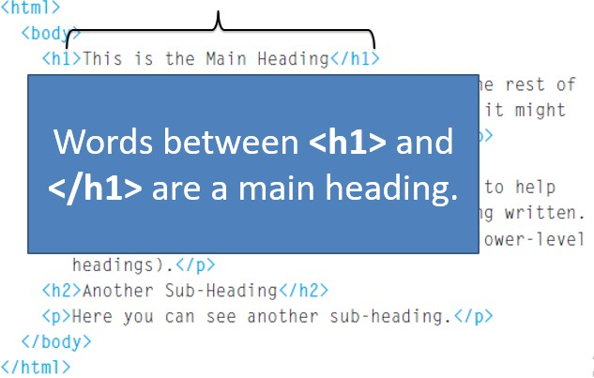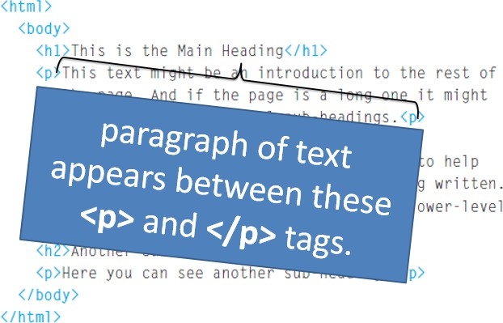

**Figure 6 HTML Tags Example 4 Figure 7 HTML Tags Example 5**

##### Attributes

Attributes provide additional information about the contents of an element. They appear on the opening tag of the element and are made up of two parts: a name and a value, separated by an equals sign.

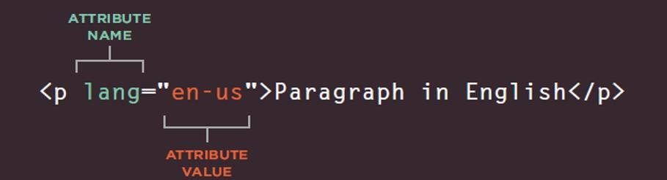

**Figure 8 Attributes**

**For Example:**

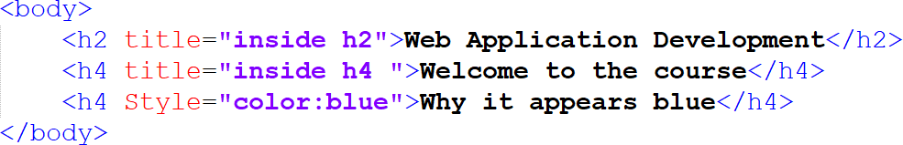

**Figure 9 HTML Code**

**Output:**

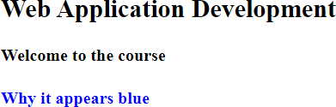

**Figure 10 Output**

##### Basic HTML Tags

###### HTML Headings

HTML has six "levels" of headings. Headings are defined with the **<h1>**to **<h6>**tags.

**<h1>**defines the most important heading. **<h6>**defines the least important heading.

**For Example:**

**Code:**

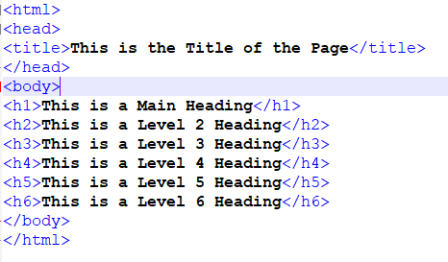

**Figure 11 HTML Code**

**Output:**

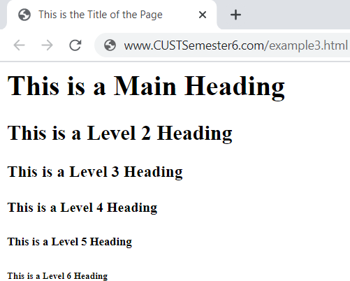

**Figure 12 HTML Code Output**

###### HTML Paragraphs

A paragraph consists of one or more sentences that form a kind of dialogue. The HTML **<p>** element defines a **paragraph**:

**Code:**

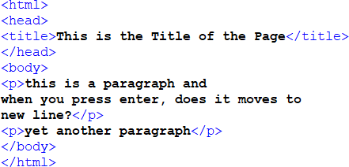

**Figure 13 HTML Code**

**Output:**

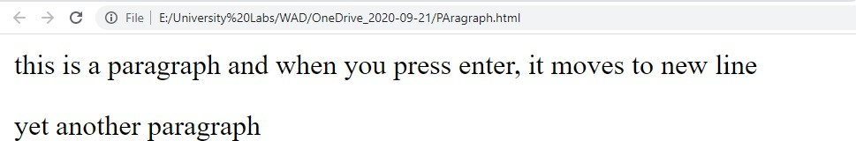

**Figure 14 Output**

###### HTML Formatting Elements

HTML uses elements like **<b>**and **<i>**for formatting output, like **bold** or *italic* text. Formatting elements were designed to display special types of text:

**<b>**- Bold text

**<strong>**- Important text

**<i>**- Italic text

**<em>**- Emphasized text

**<mark>**- Marked text

**<small>**- Small text

**<del>**- Deleted text

**<ins>**- Inserted text

**<sub>**- Subscript text

**<sup>**- Superscript text

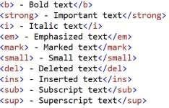

**Figure 15 Code**

###### Output:



###### Line Breaks & Horizontal Rules

**Code:**

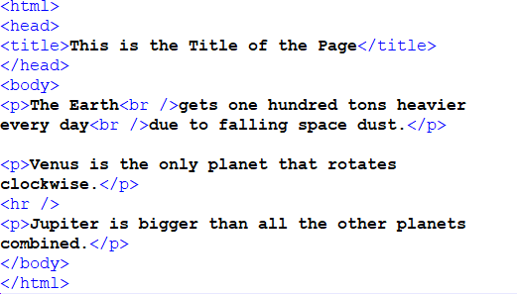

**Figure 16 HTML Code**

**Output:**

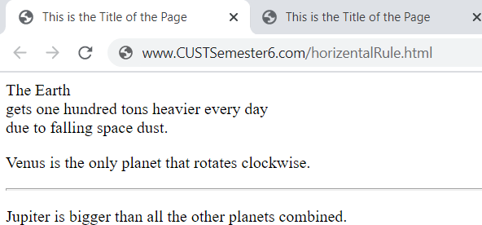

**Figure 17 Output**

###### HTML Quotations

The HTML **<q>**element defines a short quotation.

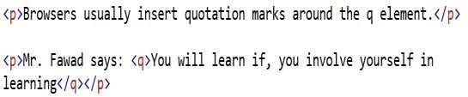

**Figure 18 HTML code**

###### Output:

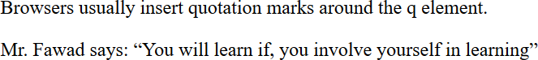

**Figure 19 Output**

The HTML **<blockquote>**element defines a section that is quoted from another source.

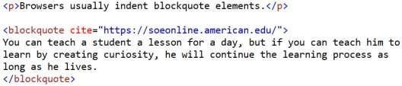

**Figure 20 Code**

###### Output:

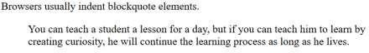

**Figure 21 Output**

###### HTML Comments

Just like other languages, HTML also provides tags to add comments

You can add comments to your HTML source by using the following syntax:

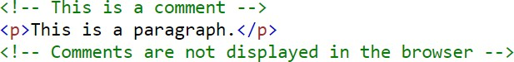

**Figure 22 HTML Comments**

**Note:** Comments are not displayed by the browser, but they can help document your HTML source code.

###### HTML Links

HTML links are hyperlinks. You can click on a link and jump to another document. When you move the mouse over a link, the mouse arrow will turn into a little hand.

**Note:** A link does not have to be text. It can be an image or any other HTML element.

/



Output:



###### HTML Images

In HTML, images are defined with the **<img>** tag. The **<img>** tag is empty, it contains attributes only, and does not have a closing tag. The **src**attribute specifies the URL (web address) of the image:



###### Output:

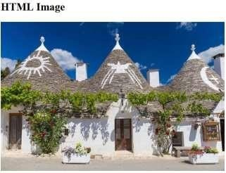

**Figure 23 Output**

The altattribute provides an alternate text for an image, if the user for some reason cannot view it (because of slow connection, an error in the src attribute, or if the user uses a screen reader).

The value of the **alt** attribute should describe the image. More helpful resource -> <https://www.w3schools.com/html/html_images_picture.asp>

###### HTML Style Attribute

Setting the style of an HTML element, be done can with the **style**attribute. The HTML

**style**attribute has the following **syntax**:



**Figure 24 HTML Code**

The ***property*** is a CSS property. The ***value*** is a CSS value.

**Note:** You will learn more about CSS later in this lab, here we will discuss 2-3 examples only.

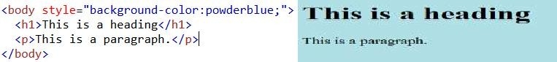

**Figure 25 HTML Code and Output**

The CSS **background-color**property defines the background color for an HTML element. Similarly, The CSS

**color**property defines the text color for an HTML element:



**Figure 26 HTML Code and Output**

###### HTML Table

An HTML table is defined with the **<table>**tag. Each table row is defined with the **<tr>**tag. A table header is defined with the **<th>**tag. By default, table headings are bold and centered. A table data/cell is defined with the **<td>**tag.

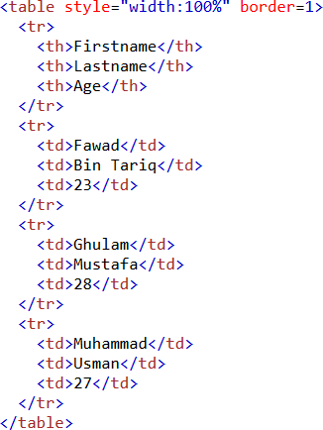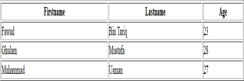

**Figure 28 Output**

**Figure 27 HTML Code**

###### HTML Lists

An unordered list starts with the [**<ul>**](https://www.w3schools.com/tags/tag_ul.asp)tag. Each list item starts with the [**<li>**](https://www.w3schools.com/tags/tag_li.asp)tag. The list items will be marked with bullets (small black circles) by default:

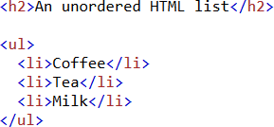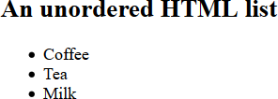

**Figure 30 HTML Code Figure 29 HTML Output**

An ordered list starts with the [**<ol>**](https://www.w3schools.com/tags/tag_ol.asp)tag. Each list item starts with the [**<li>**](https://www.w3schools.com/tags/tag_li.asp)tag. The list items will be marked with numbers by default:

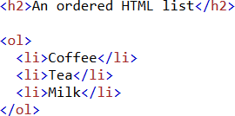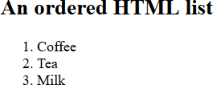

**Figure 32 HTML Code Figure 31 HTML Output**

##### HTML Forms

The HTML **<form>**element defines a form that is used to collect user input:

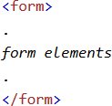

**Figure 33 HTML Code**

An HTML form contains **form elements**. Form elements are different types of input elements, like: text fields, checkboxes, radio buttons, submit buttons, and more.

###### HTML Forms (Text Fields)

**<input type="text">**defines a single-line input field for **text input**

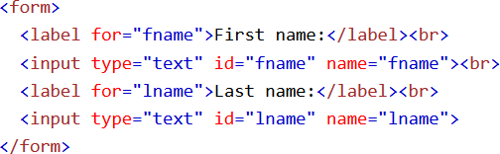

**Figure 34 HTML Code**

**Output:**

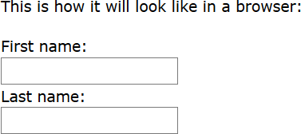

**Figure 35 Output**

Notice the use of the **<label>**element in the example above.

The **for**attribute of the <label> tag should be equal to the **id**attribute of the <input> element to bind them together.

###### HTML Forms (Radio Buttons)

**<input type="radio">**defines a **radio button**. Radio buttons let a user select ONE of a limited number of choices

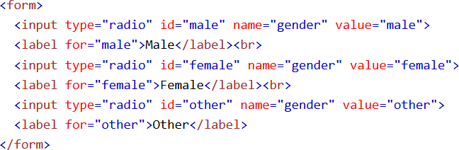

**Figure 36 HTML Code**

This is how the HTML code above will be displayed in a browser:

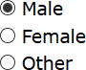

**Figure 37 Output**

###### HTML Forms (The Submit Button)

**<input type="submit">**defines a button for **submitting** the form data to a **form- handler**. he form-handler is specified in the form's **action** attribute.

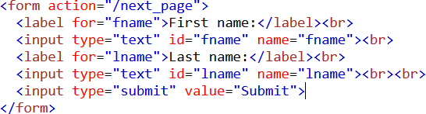

**Figure 38 HTML Code**

This is how the HTML code above will be displayed in a browser:

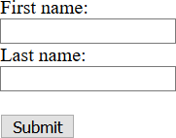

**Figure 39 Output**

###### HTML Forms (Select Element)

The **<select>**element defines a **drop-down list**:

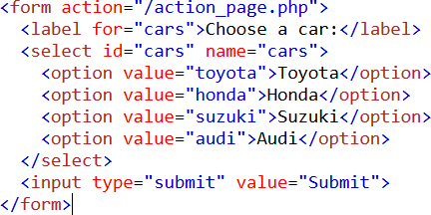

**Figure 40 HTML Code**

This is how the HTML code above will be displayed in a browser:



**Figure 41Output**

###### HTML Forms (Text Area)

The **<textarea>**element defines a multi-line input field (**a text area**):

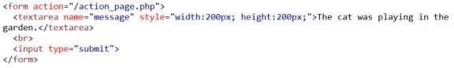

**Figure 42 HTML Code**

This is how the HTML code above will be displayed in a browser:

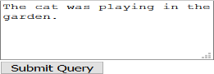

**Figure 43 Output**

###### HTML Forms (fieldset and legend)

The **<fieldset>**element is used to group related data in a form. The **<legend>**element defines a caption for the **<fieldset>**element.

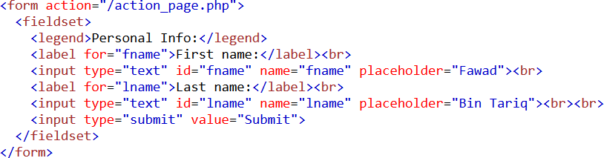

**Figure 44 HTML Code**

This is how the HTML code above will be displayed in a browser:

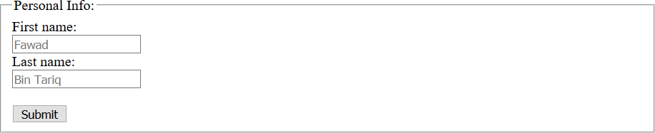

**Figure 45 Output**

###### HTML Forms (Input Types)

Here are the different input types you can use in HTML:

* + - * <input type="button">
      * <input type="checkbox">
      * <input type="color">
      * <input type="date">
      * <input type="email">
      * <input type="file">
      * <input type="hidden">
      * <input type="image">
      * <input type="month">
      * <input type="number">
      * <input type="password">
      * <input type="radio">
      * <input type="reset">
      * <input type="search">
      * <input type="submit">
      * <input type="tel">
      * <input type="text">
      * <input type="time">
      * <input type="url"

###### HTML Forms (Input Attributes)

**Value attribute:** The input **value** attribute specifies an initial value for an input field. **Readonly attribute**: The input **readonly** attribute specifies that an input field is read- only. **Disabled attribute:** The input **disabled**attribute specifies that an input field should be disabled.

**Size attribute:** The input sizeattribute specifies the visible width, in characters, of an input field. The default value for sizeis 20.

**Maxlength attribute:** The input **maxlength** attribute specifies the maximum number of characters allowed in an input field.

**Min and max attribute:** The input **min**and **max**attributes specify the minimum and maximum values for an input field.

**Multiple attribute:** The input **multiple**attribute specifies that the user is allowed to enter more than one value in an input field.

**Pattern attribute:** The input **pattern**attribute specifies a regular expression that the input field's value is checked against, when the form is submitted.

**Placeholder attribute:** The input **placeholder** attribute specifies short a hint that describes the expected value of an input field (a sample value or a short description of the expected format).

**Required attribute:** The input **required**attribute specifies that an input field must be filled out before submitting the form.

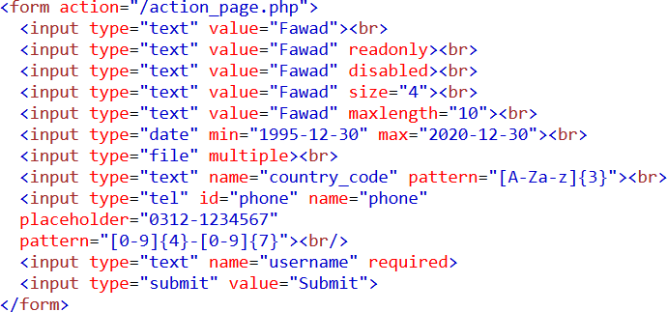

**Figure 46 HTML Code**

Can be viewed in browser as:

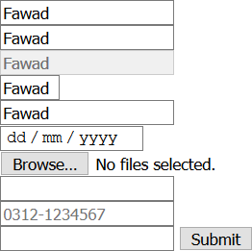

**Figure 47 Output**

##### Practice Task 01 [Expected Time 10 mins]

Design a simple form that consists of following fields:

1. 2 Input fields for your “First Name” & “Last Name”.
2. Read only field that contains your city and make it required.
3. Input field for zip code and restrict field length to 4.
4. Field for taking your date of birth
5. Input field with type “submit”

##### 

##### Practice Task 02 [Expected Time 10 mins]

* Create a Table of students and save their academic record. (5 rows 3 col)

##### Practice Task 03 [Expected Time 30 mins]

* Create a REGISTRATION PAGE AND JUMP TO LOGIN PAGE done in lab 1.
* Registration page have all necessary login details which are required in any

###### 

###### Practice Task 04 [Expected Time 10 mins]

Create a following page in html

